AEPHY2021
Narrogin SHS Year 11 ATAR PHYSICS Name:
Task No: | 10
Task Type: | Test
Content: | Linear motion and force
Task Description: | Complete the attached questions in the spaces provided.  Marks will be awarded for presentation and working.  Test conditions (50 minutes).  Formulae and data booklet provided.  Non-programmable calculator permitted.
Total Marks: | 30
Weighting: | 6%
Materials required | pens, pencils (including coloured), sharpener, correction fluid, eraser, ruler, highlighters, scientific calculator
Due Date:

Answer the following questions in the spaces provided

- A boat, that is capable of travelling at 8.0 km h⁻¹ in no current, heads directly across a river that is 1400 m wide. The current is flowing at 6.0 km h⁻¹ at right angles to the boat. What is the boat’s speed in ms⁻¹?
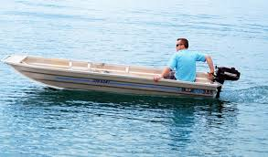

(3 marks)

- A 10kg weight was dropped from a hot air balloon that had an altitude of 3000m. How long did it take for the weight to hit the ground?



(3 marks)

- A student threw an 80 g ball vertically upwards with a velocity of 25 ms⁻¹. Calculate the maximum height achieved by the ball.



(3 marks)

- A 50 kg go-cart crashes into a 40 kg go-cart which is travelling in the same direction at 1.2 m s⁻¹. The front cart moves off at 1.8 m s⁻¹ while the back cart continues at 1.5 m s⁻¹. Calculate the initial velocity of the 50 kg go-cart.
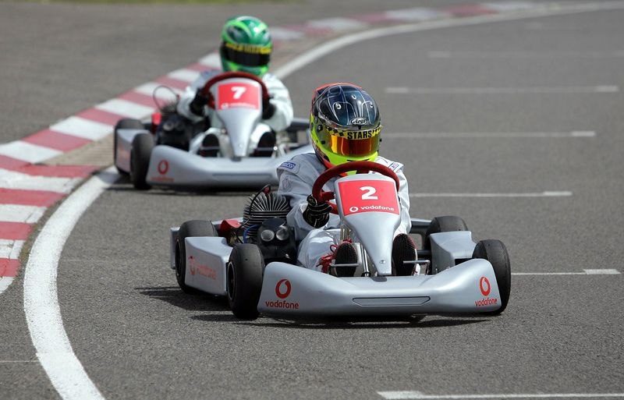

(3 marks)

- An inexperienced engineer designed a rollercoaster track. A rollercoaster starts rolling along a horizontal length of track at 5 ms⁻¹ and 20m above the ground. The car then travels down a sloping part of the track to ground level and then rolls along a level section of track. After 10m of track the rollercoaster car travels up a vertical section of track. You may assume the mass of the car.

Rough diagram:

5 ms⁻¹

20 m

- Sketch a velocity vs. time graph to show the motion of the rollercoaster.

(2 marks)

- How fast is the rollercoaster car travelling at the bottom of the slope?

(3 marks)

- How high up the vertical section will the car travel before it rolls back down towards the ground section?

(3 marks)
- An electrical engineer is designing a winch that is to be used for lifting heavy mining carts up a vertical shaft. The carts will have a maximum weight of 800 kg and the shaft is 400 m deep.
The winch needs to be powerful enough to lift the cart up 400 m in 2 minutes.
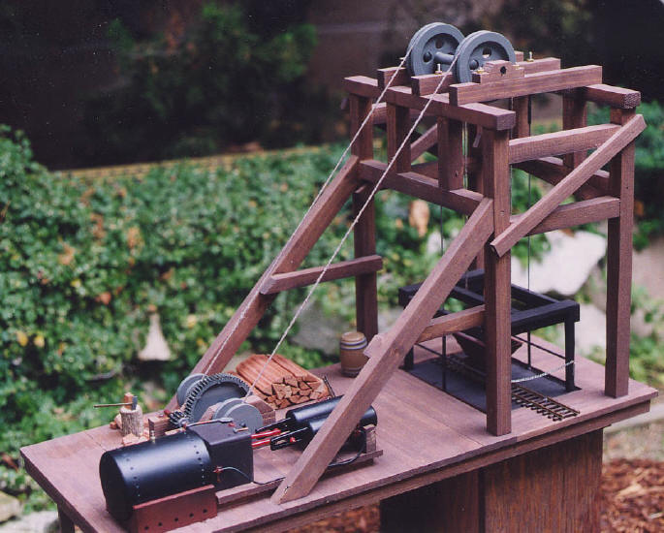

- Calculate the amount of energy needed to lift one cart that is loaded to the maximum limit.

(3 marks)

- Calculate the minimum power rating of the winch

(2 marks)

- A F1 car (440 kg) travelling at 200 km h⁻¹ can come to a complete stop in 2.21 seconds.

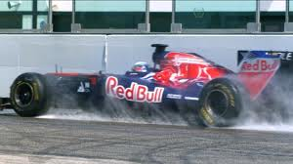

- Calculate the amount of force needed to slow the car down.

(2 marks)

- Determine the braking distance (not including driver reaction time)

(3 marks)

END OF TEST

